State of the IOTC Yellowfin Reference Set Operating Model for Management Procedure evaluation Sep 2019

Dale Kolody (dale.kolody@csiro.au)
Paavo Jumppanen
CSIRO, Australia

Introduction
This document provides a brief description of the most recent state of the yellowfin tuna reference set Operating Model (OM) used for Management Procedure (MP) evaluation, OmRefY19.4.500. The documentation for the latest version of the MSE software, technical documentation, and series of project reports is publicly available from github https://github.com/pjumppanen/niMSE-IO-BET-YFT/. The iterative and sometimes circuitous decision process undertaken by the IOTC technical working groups and analysts to reach the current state of the OM are not described here. These may be found in various IOTC working papers, information papers and meeting reports, along with various model results and diagnostics that were used to guide the OM development process.
OmRefY19.4.500 was proposed by the MSE task force in March 2019, and represents a modest improvement to the OM used to provide MP evaluations for the TCMP in May 2019 (more extensive uncertainty grid structure and some minor bug/specification fixes). The definition and role of the robustness tests is continuously evolving and not described here.

Conditioning Software
This version of the OM is an ensemble of models conditioned using the Stock Synthesis assessment software version SS3.24z.exe (e.g. Methot and Wetzel 2013).

Projection Software
The projection software is available from https://github.com/pjumppanen/niMSE-IO-BET-YFT/. The population dynamics equations conform to fairly standard assumptions, and are fully documented in the technical reference (also on github).

Reference Case OM
The various models in the OM ensemble are derived from the reference case stock assessment (supplied by Dan Fu, IOTC secretariat, and defined in Fu et al (2018)). Key assumptions include:
- 4 regions (Figure 1) with age-dependent movement
- Quarterly dynamics (implemented with calendar quarters as SS model-years)
- 25 fisheries (Table 1) - 21 with some temporal variation represetned as independent fisheries
- Parameter estimation objective function includes
  - Total catch penalty (if some component of catch cannot be removed)
  - Standardized longline CPUE (one series per region)
  - Size composition data
  - Tags (down-weighted to be essentially excluded in some OM scenarios)
  - Recruitment penalties on deviations from stock recruit relationship and mean spatial distribution
  - Diffuse priors on all estimated parameters
- Estimated parameters:
  - Fishery selectivity (various functional forms, parameters shared among some fleets)
  - Longline catchability (in aggregate - regional scaling factors are used to scale relative density to relative abundance among regions)
  - Virgin recruitment
  - Recruitment deviations from the Beverton-Holt stock-recruit relationship, recruitment spatial partitioning among tropical regions (1 and 4) and deviations from the mean spatial distribution.
  - Juvenile and adult movement rates
  - Initial fishing mortality
- Modifications to the reference case for the base of the OM included removing the movement-environment link and relaxing some bounds (i.e. so that an arbitrary hard bound does not constrain parameter estimates).

OM Reference Set Grid
- Model structural and parameter uncertainty is introduced to the OM through the alternative assumptions listed in Table 2. Only the point estimates (maximum posterior density) of parameters and states from each model specification are retained for the OM.
- A fractional-factorial experimental design was used to calculate a subset of 1152 models, which would allow the estimation of all main effects and 2 way interactions in the context of a GLM (the full factorial grid with all interactions would require 4608 models).
- In recognition that the IOTC yellowfin assessment model parameter estimates can be sensitive to initial starting conditions, minimization was repeated from randomly jittered starting conditions until either (i) successful minimization was achieved 3 times (maximum gradient of the objective function with respect to the estimated parameters <0.01) or (ii) 10 attempts were made without reaching 3 successful minimizations. Approximately 10% of models failed to converge.

OM Reference Set OMrefY19.4.500
- Within an individual model configuration, the version with the lowest objective function value (from the jittered minimizations) were retained (initially)
- The best fit models were subsequently rejected from the reference grid if:
  - Minimization unsuccessful (max. grad. >0.01)
  - SS3 Catch Penalty >1E-5 (i.e. model struggles to remove the observed catch, which is assumed to be related to the pessimistic retrospective patterns)
  - The aggregate annualized CPUE CV exceeded 0.3. This is an arbitrary value that affected a small number of models, most of which were associated with high MSY outliers.
- All retained models were subject to a qualitative comparison of simple diagnostics to identify outlier behaviour or polymodal stock status inferences (no major problems were noted). The four most extreme models (highest and lowest depletion and productivity) were visually examined in more detail, without obvious evidence for blatant model failure.
- The OM reference set grid is fully balanced with respect to each factor, while the retained grid has 420 of the original models, with the factor level distribution shown in Table 4. Rejected models were disproportionately associated with options M06, i1 and gr1.
- Each SS model was assigned a plausibility weighting (to date, models have only been assigned a weighting of 0 or 1, such that all retained models are uniformly weighted). OmRefY19.4.500 consists of 500 models randomly sampled (with replacement) from the grid of retained models.
- Key projection assumptions are summarized in Table 4 (values not presented conform to the SS model assumptions or estimates).

References
Fu, D, Langley, A, Merino, G, Urtizberea, U, 2018. Preliminary Indian Ocean yellowfin tuna stock assessment 1950-2017 (stock synthesis). IOTC–2018–WPTT20–33.

Methot, R.D., Wetzel, C.R. 2013. Stock synthesis: A biological and statistical framework for fish stock assessment and fishery management. Fisheries Research 142 (2013) 86–99.

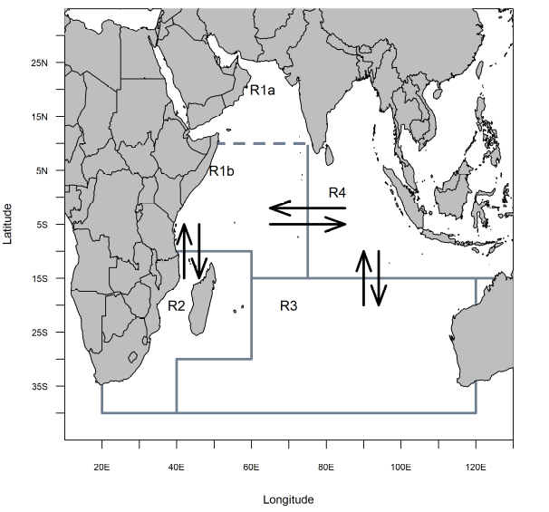
Figure 1. Spatial structure for the yellowfin tuna OM (figure from Fu et al. 2018).

Table 1. IOTC Yellowfin assessment fishery definitions.
Fishery | Definition | Region
1 | Gillnet (GI) | 1
2 | Handline (HD) | 1
3 | Longline (LL) | 1
4 | Other (OT) | 1
5 | Baitboat (BB) | 1
6 | Purse-seine - free schools (FS) 2003-2006 | 1
7 | Longline (LL) | 1
8 | Purse-seine - log schools (LS) 2003-2006 | 1
9 | Troll (TR) | 1
10 | Longline (LL) | 2
11 | Longline (LL) | 3
12 | Gillnet (GI) | 4
13 | Longline (LL) | 4
14 | Other (OT) | 4
15 | Troll (TR) | 4
16 | Purse-seine - free schools (FS) | 2
17 | Purse-seine - log schools (LS) | 2
18 | Troll (TR) | 2
19 | Purse-seine - free schools (FS) | 4
20 | Purse-seine - log schools (LS) | 4
21 | Purse-seine - free schools (FS) pre 2003 | 1
22 | Purse-seine - log schools (LS) pre 2003 | 1
23 | Purse-seine - free schools (FS) post 2006 | 1
24 | Purse-seine - log schools (LS) post 2006 | 1
25 | Longline - fresh tuna (LL) | 4

Table 2. Assumptions in OMrefY19.4.500 Stock Synthesis conditioning. Bold indicates the reference case assumption from the Fu et al (2018) assessment.
Abbreviation | Definition
h70  h80  h90 | Stock-recruit function (h = steepness)  Beverton-Holt, h = 0.7  Beverton-Holt, h = 0.8  Beverton-Holt, h = 0.9
M10  M08  M06 | Natural mortality multiplier relative to reference case M vector  1.0  0.8  0.6
t0001  t10 | Tag recapture data weighting (tag composition and negative binomial)  λ = 0.001  λ = 1.0
gr1  gr2 | Growth curve  Fonteneau (2008)  Dortel et al. (2015)
q0  q1 | Assumed longline CPUE catchability trend (compounded)  0% per annum  1% per annum
iH  iC | Tropical longline CPUE standardization method  Hooks Between Floats  Cluster analysis
i3  i1 | Longline CPUE error assumption (quarterly observations)  σ_{CPUE} = 0.3  σ_{CPUE} = 0.1
iR1  iR2 | longline CPUE Regional-scaling factors  reference case  alternate
x4  x8 | Tag mixing period  4 quarters  8 quarters
SL  SD | Longline fishery selectivity  Stationary, logistic, shared among areas  Stationary, double-normal (potentially dome-shaped), shared among regions
ESS5  CL75 | Size composition input Effective Sample Sizes (ESS)  ESS = 5, all fisheries  ESS = One iteration of re-weighting from reference case model (fishery-specific), raised to the power of 0.75, capped at 100.

Table 3. Frequencies of reference set grid assumptions retained after convergence and plausibility criteria are applied. If all models were retained, each assumption would be equally represented (i.e. either 0.33 or 0.5, depending on the number of assumption levels). Assumption abbreviations are defined in Table 3.
Model Assumption
(proportion represented in OMrefY19.4)
h70  0.35 | h80  0.35 | h90  0.32
M06  0.24 | M08  0.43 | M10  0.33
t0001  0.46 | t10  0.54
i1  0.28 | i3  0.72
iC  0.53 | iH  0.47
iR1  0.52 | iR2  0.48
q0  0.56 | q1  0.44
gr1  0.25 | gr2  0.75
CL75  0.56 | ESS5  0.44
x4  0.50 | x8  0.50
SD  0.57 | SL  0.43

Table 4. OM Projection assumptions in the yellowfin reference set and robustness sets. Reference set values not listed are identical to the model-specific conditioning assumptions/estimates. Robustness case values not are identical to the reference set except as noted.
OM | Projection assumption | Value
OMrefY19.4 | Reference set OM
 | Initial population error CV  (a = age in quarters) | 0.6exp(-0.1a)
 | Recruitment deviation penalty  Recruitment deviation lag(1) auto-correlation  (annual equivalents) | σ_{R} = 0.42  ρ_{R} = 0.21
 | CPUE observation error  CPUE observation error lag(1) auto-correlation  (annual) | σ_{R} = 0.2  ρ_{R} = 0.5
 | Multinomial Catch-at-length sample size  (all fisheries) | 100
 | Selectivity stationary for all fisheries
 | Quota Implementation error | CV = 0
 | First MP quota year | 2021
 | Assumed catches 2018-2020 | 409 Kt
 | MP data lag  (i.e. data from 2018 informs 2021 quota) | 2 years*
 | Quota allocation (average observed over) | 2016-2017
*Results presented to TCMP 2019 erroneously had a 3 year data lag.

